Required fixes

* 1. getCells()

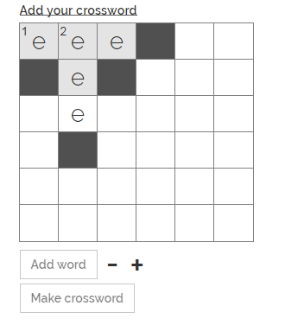

Issue: deleting clue 2 does not delete number due to branching related crosspoints and 0 indexing on first letter.

* 1. validateByAxis() on applies on clicks, not selections.

------------resolved--------------

Solution:

1. add to selections
2. all clues must have at least one cross-point else show alert
3. selections must begin with click if clueCounter.length > 1.

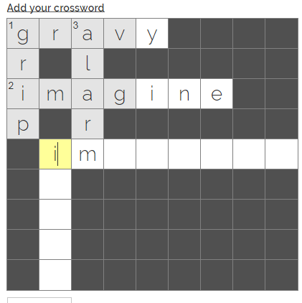

* 1. decreaseSize()

Problem: decreaseSize btn affects the setNoReinit function and results in 2 current selectable cells becoming unselectable on size decrease.

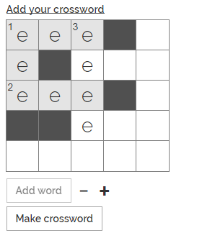

Solution: tba